Research Job Recruitment Portal

Bhagya Govindaraju - 700776985

Akhila Abbagani - 700774399

Saketh Kudupudi

Contents

**1.** **Introduction and Project Description**…...…………………………………………………...1

Core Functionalities…………………………………………………………………………...1

Benefits of job recruitment (as a Microservice Example)…………………………………….1

**2. Output from Running the Code and Screenshots…………………………………………...2**

Running the Application…………… … ……………………………………………………2

Prerequisites…………………………………………………………………………………...2

Run the Startup Script………………………………………………………………………....2

Access the Application………………………………………………………………………..2

Backend Services……………………………………………………………………….....2

Frontend UI………………………………………………………………………………..3

Screenshots: 3

**3. Code Structure, Features, and Technologies Used:…………………………………………7**

Technologies Used…………………………………………………………………………….7

Code Structure……………………………………………………………………………… 7

Backend ………………………………………………………………………………………7

1. application service…………………………………………………………………… 8

2. student-service………………………………………………………………………… 9

3. job-service:…………………………………………………………………………….10

Frontend (job portal-ui)………………………………………………………………………11

**4. Steps in Developing the Code………………………………………………………………..11**

1. Requirement Gathering……………………………………………………………………11

2. System Design:……………………………………………………………………………11

3. Environment Setup:……………………………………………………………………….12

4. Frontend Development:…………………………………………………………………...12

5. Backend Development:……………………………………………………………………13

6. Database Integration:…………………………………………………………………… 14

7. Testing and Debugging:……...……………………………………………………………14

**5. References Used……………………………………………………………………………** **1****5**

# **Introduction and Project Description**

Research job recruitment is a microservices-based web application designed specifically for colleges to facilitate the recruitment of students into research jobs and projects. The platform will provide a centralized, user-friendly interface where professors can post research opportunities with detailed descriptions, eligibility criteria, and application instructions. Students can browse available projects or jobs, apply directly through the system, and track their application status. This research job recruitment project aims to establish a structured system within colleges that efficiently connects undergraduate and graduate students with faculty-led research opportunities across diverse disciplines. The project will focus on promoting awareness of available research roles, simplifying the application and selection process, and providing support to both students and professors throughout the engagement.

## **Core Functionalities:**

* **Research Job Posting and Browsing:** Professors can create detailed research job postings including project description, eligibility criteria, duration, and benefits.Students can browse, filter, and search research opportunities based on discipline, project type, duration, and other preferences.
* **Application and Selection Management:** Students can apply directly through the platform.Professors can review applications, shortlist candidates, and communicate decisions. Status tracking for applications (Applied, Rejected, InProgress, Hired).
* **Microservice Interaction:** Demonstrates communication between services (Application Service calls Student Service for map the student Id with Student name and Job Service for map the Job title).

## **Benefits of Research Job Recruitment (as a Microservice Example):**

* **Modularity:** Each service focuses on a specific domain, such as job management or user profiles, simplifying development and updates.
* **Scalability:** Services like Jobs or Communication can be scaled independently to handle peak loads during recruitment seasons.
* **Fault Isolation:** Failure in one microservice (messaging) does not bring down the entire system, improving reliability.
* **Flexible Technology Stack:** Different microservices can use the best-suited technologies or frameworks, Spring Boot for backend services, Angular for front-end portals.
* **Seamless Integration:** Well-defined APIs enable smooth communication between services and integration with existing college systems.

# **2. Output from Running the Code and Screenshots**

# Need to run the 3 microservices which are running in different ports. We are using Maven for build and deployment.

## **Prerequisites:**

1. **Java Development Kit (JDK):** Version 17 or later (as inferred from typical Spring Boot 3+ projects).
2. **Apache Maven:** Required to build the Java services. Ensure mvn command is available in your PATH.
3. **Git:** To clone the repository (assumed).
4. **Visual Studio and Eclipse.**
5. **MySQL Client or XAMPP.**

## **Run the Project:**

Execute the script from the project root directory.

1. Start the MySQL service.
2. Need to navigate into each service directory (Student-service, Job-service, Application-service) and run mvn clean package -DskipTests to build the executable JAR files.

## **Access the Application:**

### Backend Services:

* + Job Service: http://localhost:8085
  + Student Service: http://localhost:8086/applications
  + Professor Service: http://localhost:8087/students

Database: Accessible externally on localhost.

### **Frontend UI:**

You need to start the React development server separately. The UI will typically be available at http://localhost:3000/

## **Screenshots:**

**Professor Dashboard – CRUD operations**

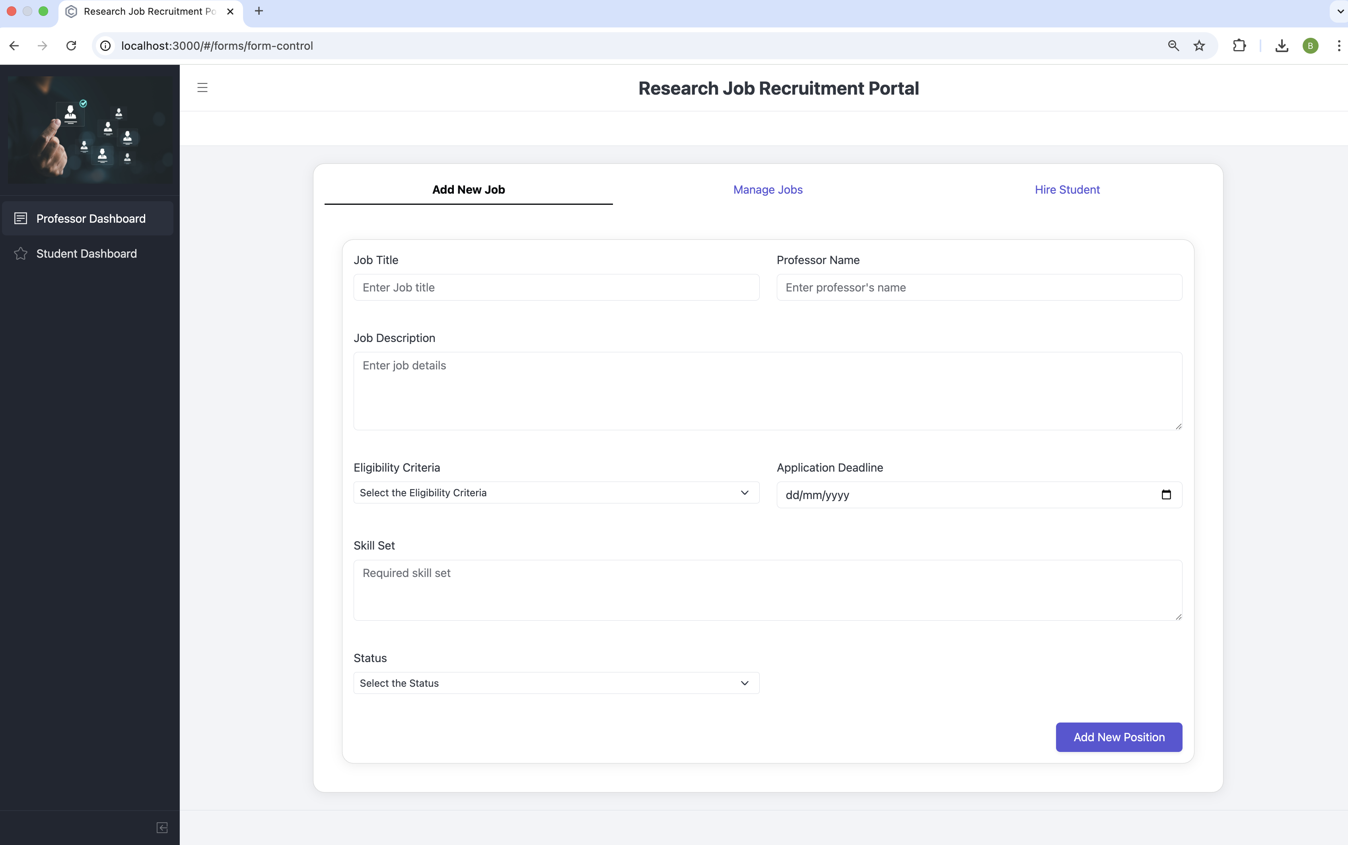

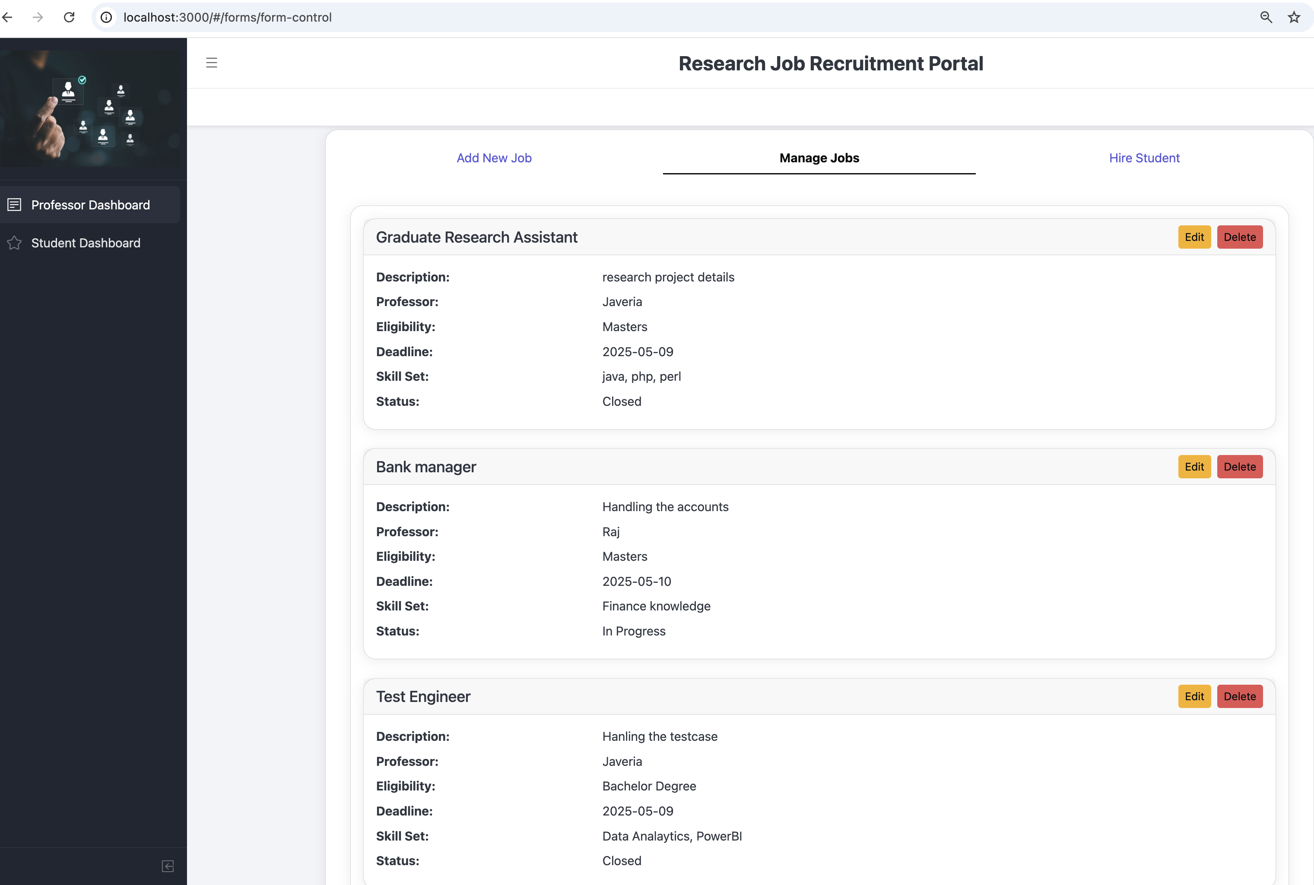

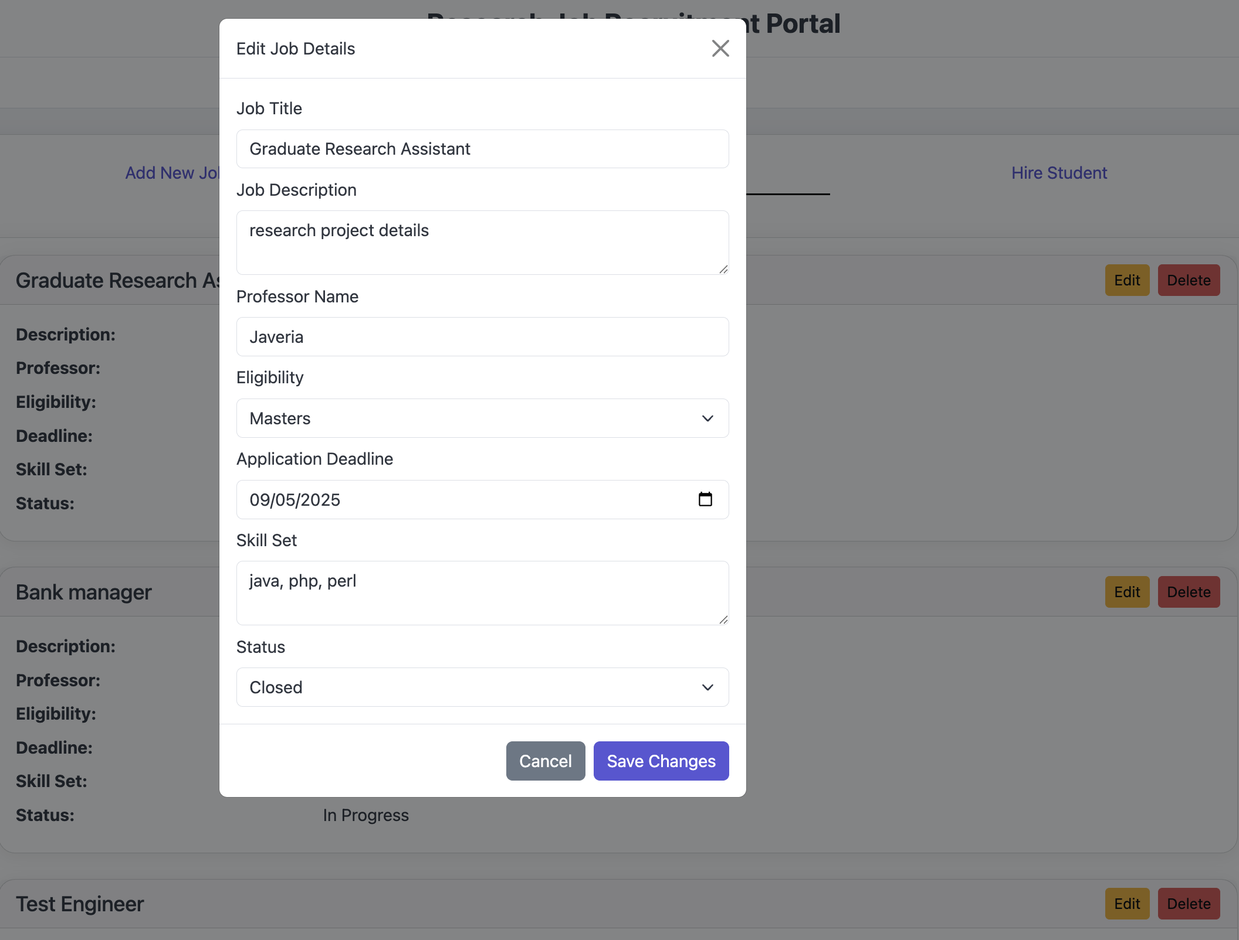

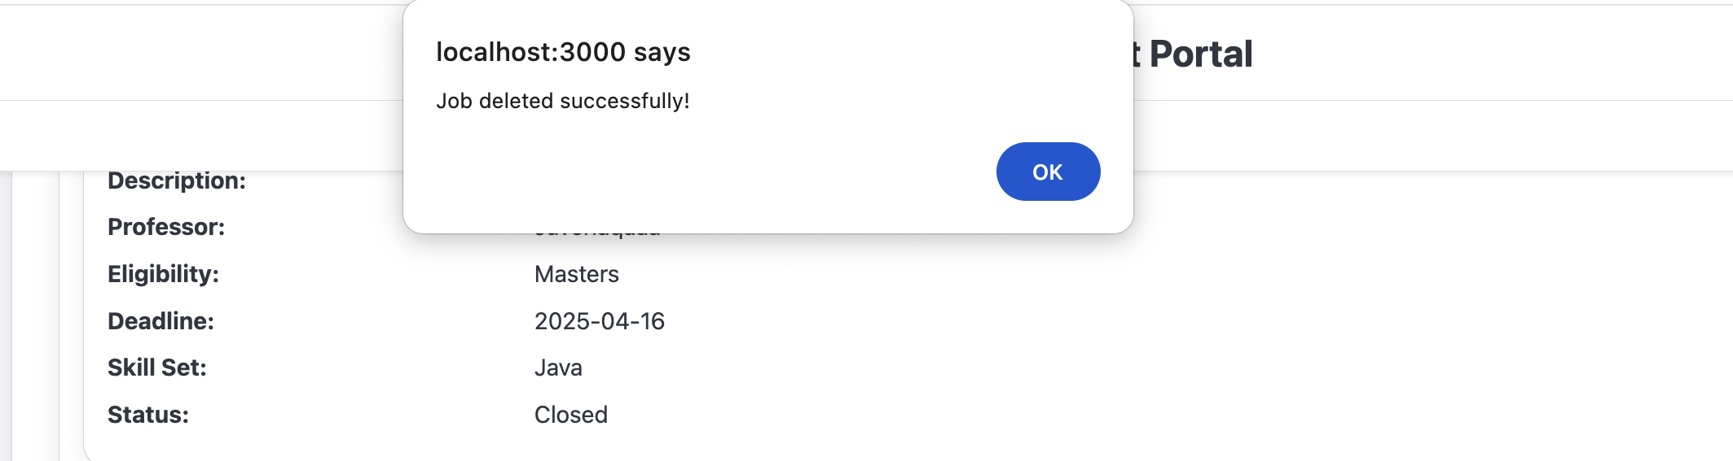

**Managing Student Applications**

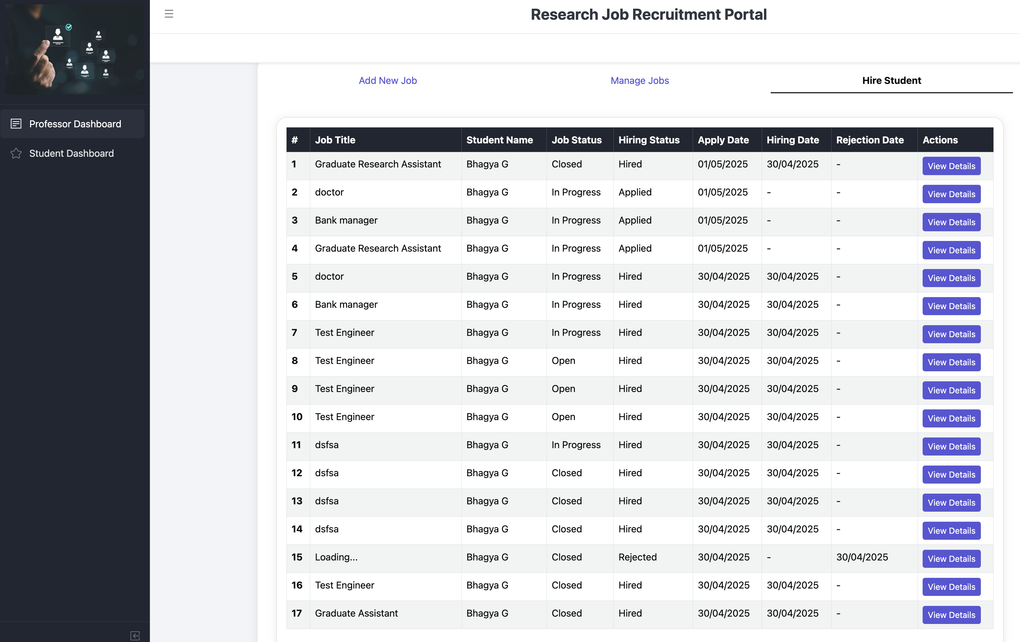

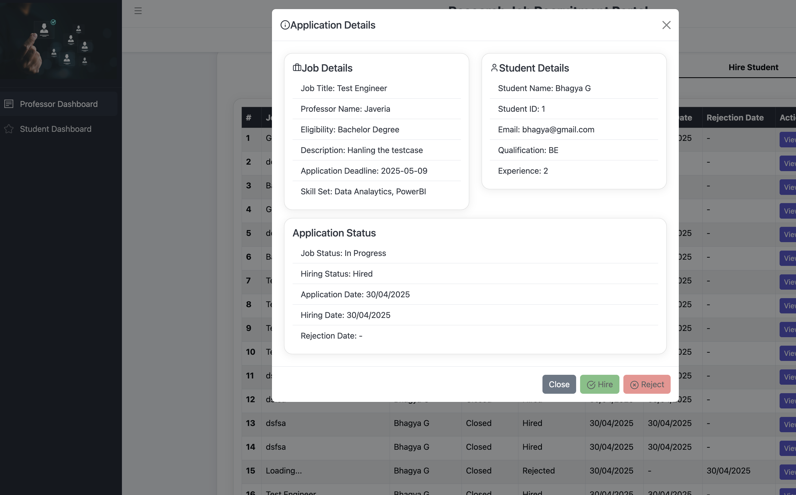

**Student Dashboard. – Apply the research jobs and track the application details.**

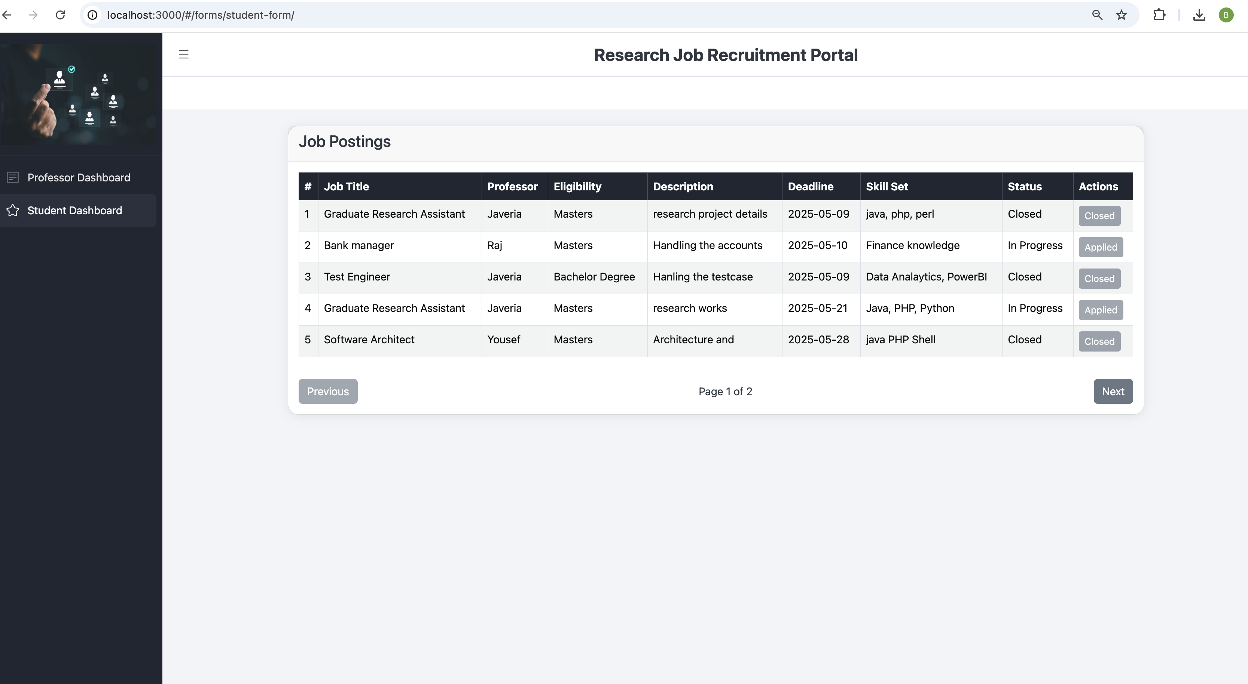

# **3. Code Structure, Features, and Technologies Used:**

## **Technologies Used**

* **Backend:** Spring Microservices
* **Frontend:** React
* **Database :** MySQL

## **Code Structure**

The project follows a microservices architecture with a separate frontend application.

## **Backend Code:**

Located in the root directory, consisting of three main Spring Boot microservices:

### **application-service: Running on port 8086**

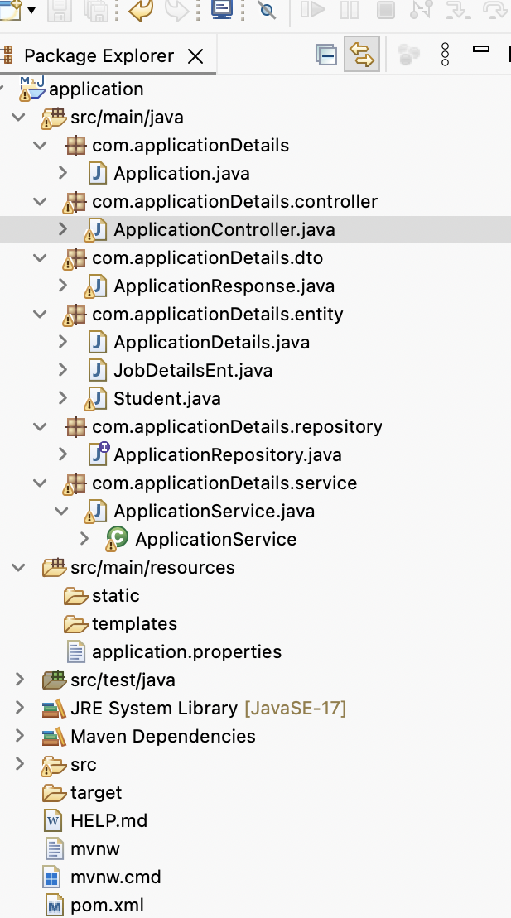

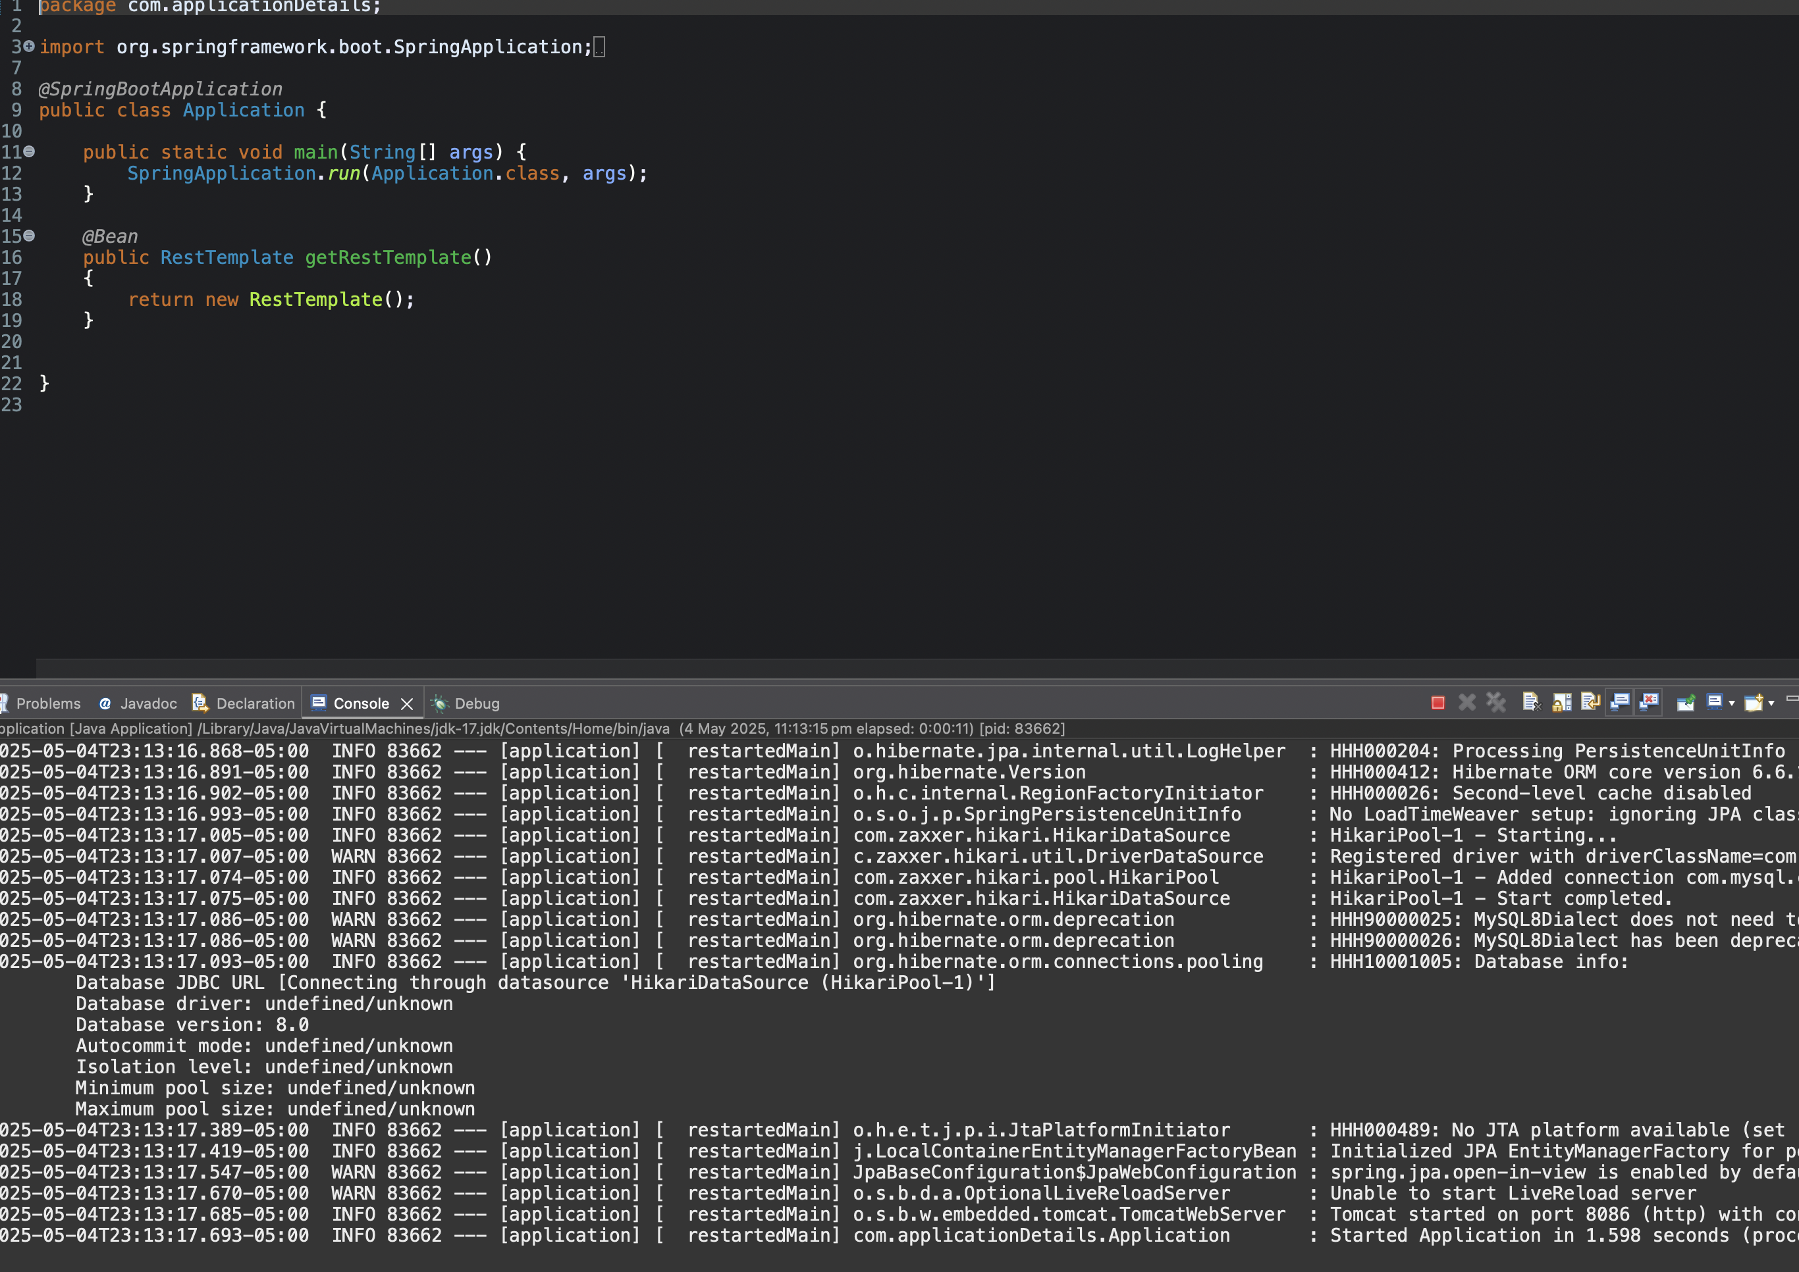

### **student-service: Running on port 8087**

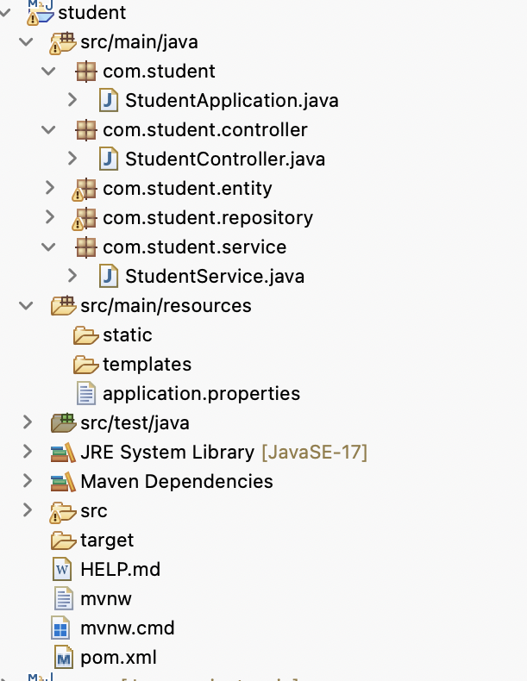

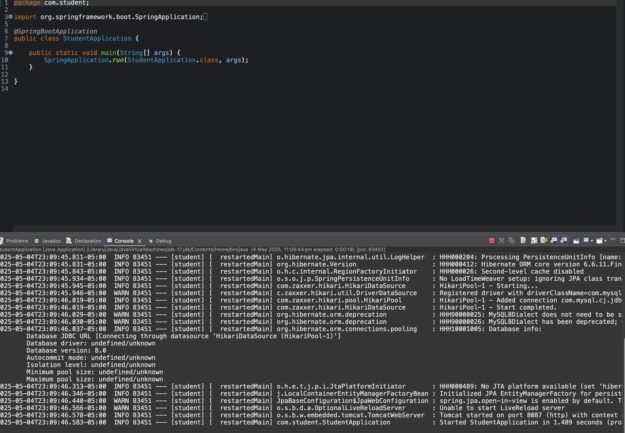

### **job-service: Running on port 8085**

## 

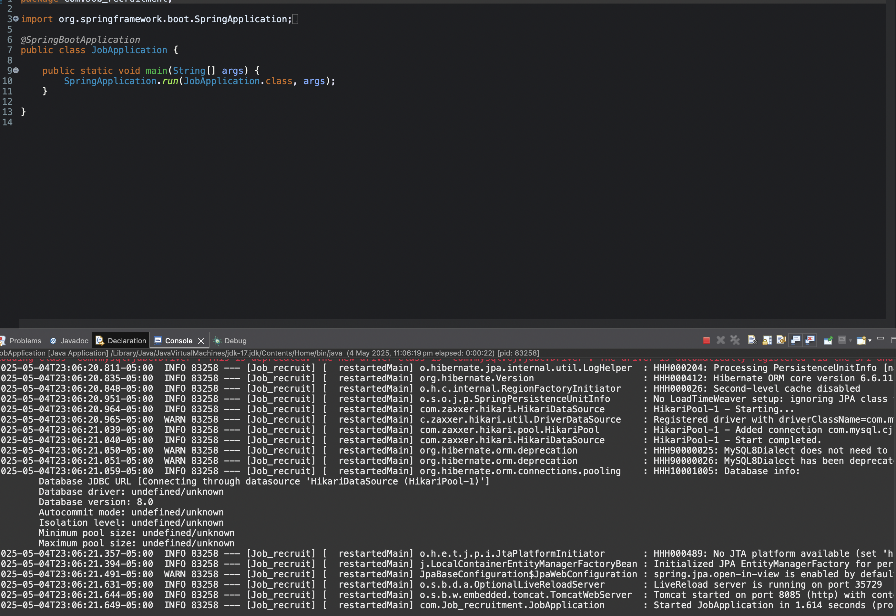

## **Frontend Code:**

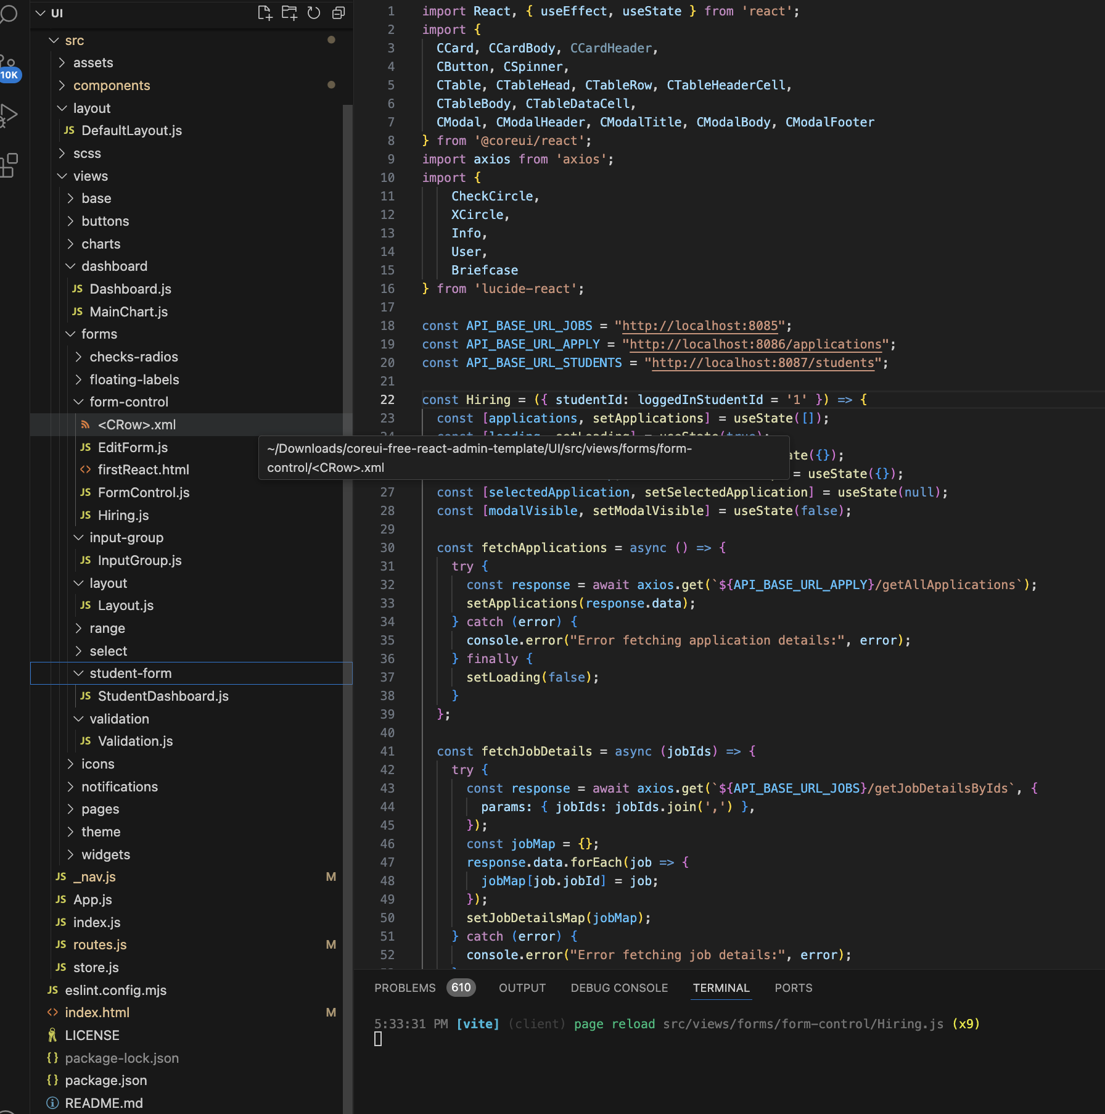

**4. Steps in Developing the Code**

1. **Requirements Gathering**
   * Identified features like user login, job posting, and application tracking.
2. **System Design**
   * Created DB called recruitment.
   * Defined database schema (students, job_details, applications tables).
3. **Environment Setup**
   * Chose tech stack ( React for frontend, Spring Boot for backend, MySQL for the database).
   * Set up local development environment (using XAMPP, Postman for API testing).
4. **Frontend Development**
   * Designed UI with login, job post listings, and application details.
   * Implemented state management and API integration.
5. **Backend Development**
   * Created REST APIs for user authentication, job posting, and application submission.
   * Implemented business logic and validation rules.
6. **Database Integration**
   * Connected backend to database, created tables, and implemented CRUD operations.
7. **Testing and Debugging**
   * Performed unit testing, integration testing, and fixed bugs.

# **5. References Used**

While specific URLs were not provided in the input, the development of this project would typically rely heavily on the official documentation for the core technologies used:

* **Spring Boot:**<https://spring.io/projects/spring-boot>
* **Spring Data JPA:**<https://spring.io/projects/spring-data-jpa>
* **Spring Security:**<https://spring.io/projects/spring-security>
* **React:**<https://reactjs.org/docs/getting-started.html>
* **React Router:**<https://reactrouter.com/>
* **React Bootstrap:**<https://react-bootstrap.github.io/>
* **Axios:**<https://axios-http.com/docs/intro>
* **Maven:**<https://maven.apache.org/guides/index.html>